Assignment 2: Create Your First Java Program - Hello World

Student Information
- Name: Krishnan Madhuratnam
- Section: 2cse22
- Roll Number: 25scs1003001176
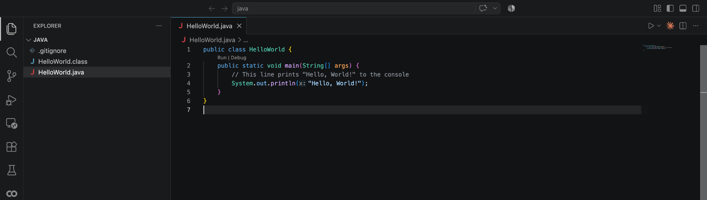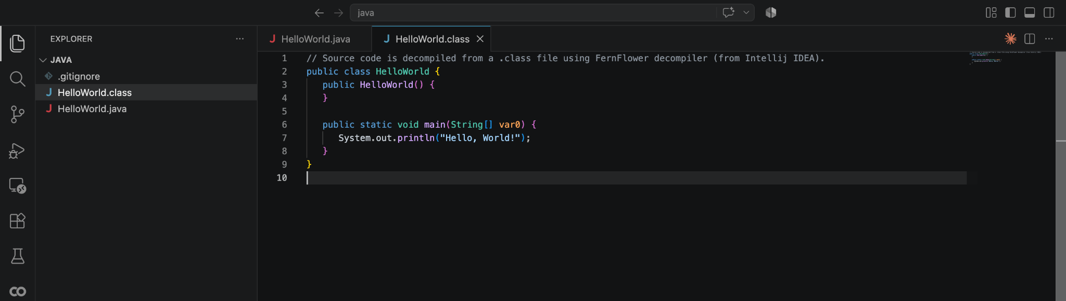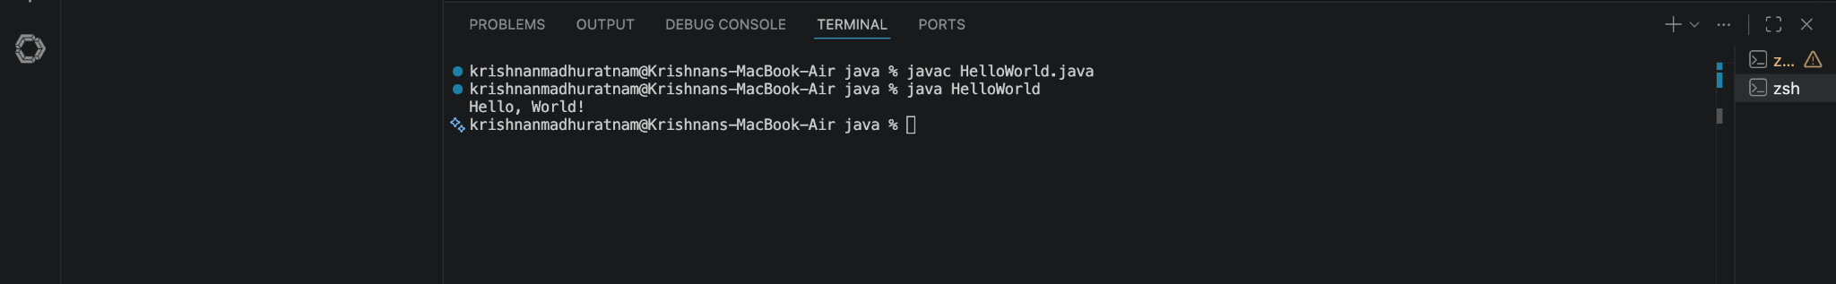
All steps for the source code have been completed; here is the image of the Java source code.
All steps for the class file have been completed; here is the image of the decompiled .class file.
All steps for compilation and execution have been completed; here is the image of the terminal output and the resulting "Hello, World!" message.

Explanation
- What is a Java program? A Java program is a set of instructions written in the Java programming language. Once compiled, it can run on any device that has a Java Virtual Machine (JVM) installed, making it platform-independent.
- What is the purpose of the main() method? The main() method serves as the entry point for any Java application. It is the specific block of code that the Java Virtual Machine (JVM) looks for and executes first when the program starts.
- What is the difference between javac and java? javac is the Java compiler; it takes human-readable source code (.java files) and converts it into bytecode (.class files). The java command is the launcher; it runs the compiled bytecode on the Java Virtual Machine.

